附件：

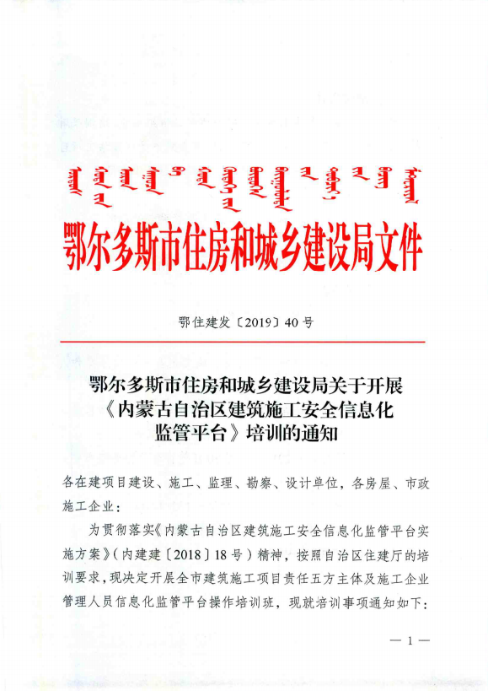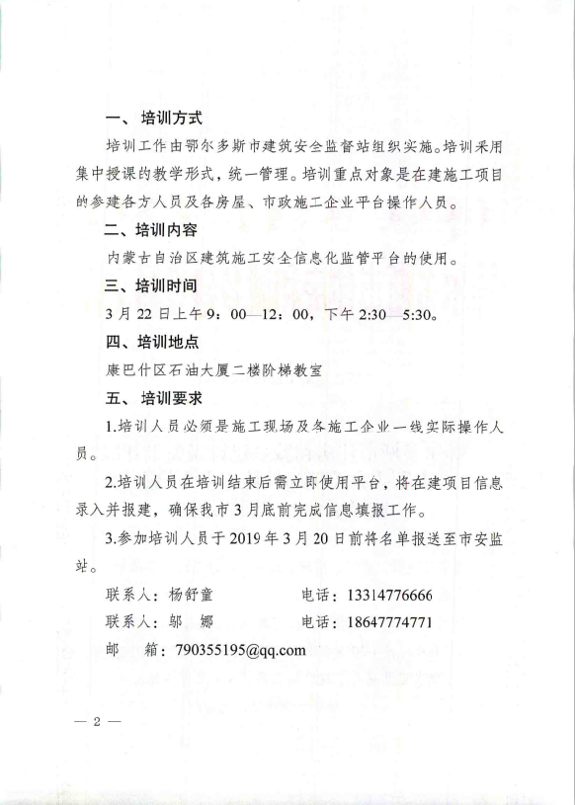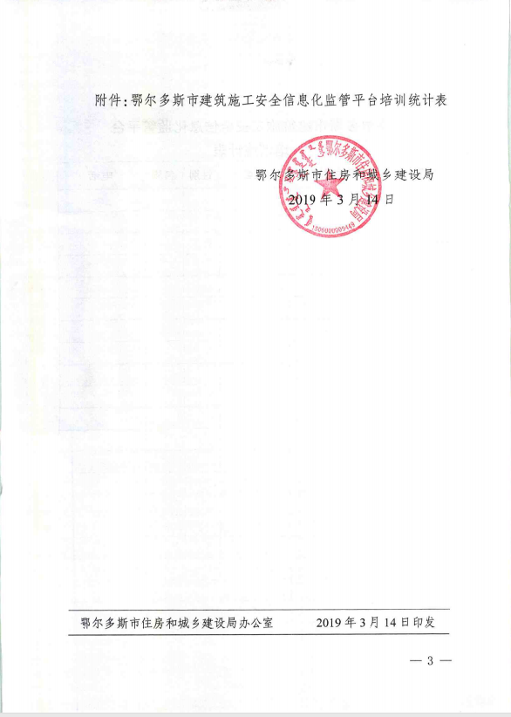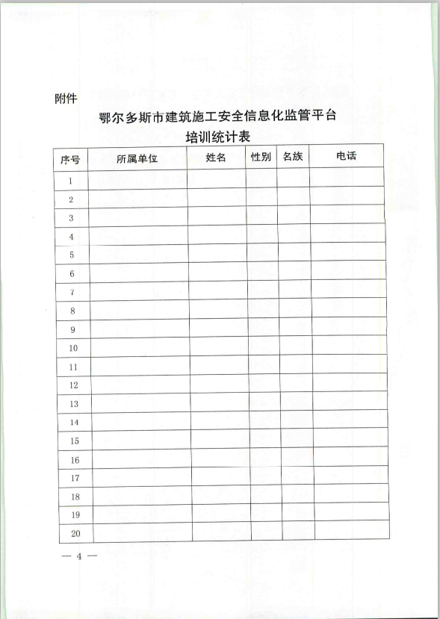

附件：

**鄂尔多斯市建筑施工安全信息化监管平台培训统计表**

|  |  |  |  |  |  |
| --- | --- | --- | --- | --- | --- |
| **序号** | **所属单位** | **姓名** | **性别** | **民族** | **电话** |
|  |  |  |  |  |  |
|  |  |  |  |  |  |
|  |  |  |  |  |  |
|  |  |  |  |  |  |
|  |  |  |  |  |  |
|  |  |  |  |  |  |
|  |  |  |  |  |  |
|  |  |  |  |  |  |
|  |  |  |  |  |  |
|  |  |  |  |  |  |
|  |  |  |  |  |  |
|  |  |  |  |  |  |
|  |  |  |  |  |  |
|  |  |  |  |  |  |
|  |  |  |  |  |  |
|  |  |  |  |  |  |
|  |  |  |  |  |  |